**Monadnock READS Summer 2015**

Dear Parents and Students, 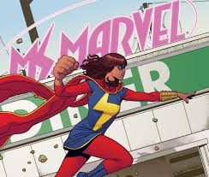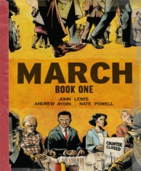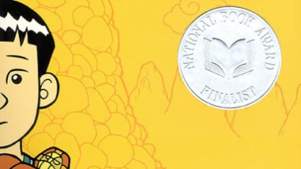

The Monadnock READS summer reading program is a very important component in your child’s learning experience at MRMHS. This summer, the high school English teachers have decided to explore race, stereotypes, and cultural differences through the genre of the graphic novel. Although we know that our students are bombarded with media about racial and cultural stereotypes, differences, and conflicts, we rarely discuss these topics in a purposeful and educational way.

It is our hope that you will also read the graphic novel your son or daughter chooses. It would be great to start the discussion at home before we discuss the books in English classes in the fall. However, there will be an opportunity for a community discussion through Google Classroom (classroom.google.com). All you and your child need is the code to join the class. Here is the code: **jb97mz**. We will share information about the books, links, and an opportunity for discussion over the summer. We hope that you and your child will join us!

In-coming ninth graders are required to read *March*. Students entering grades 10-12 will choose from *March*, *Ms. Marvel*, and *American Born Chinese*. However, students can certainly read all three if they wish.

**In-coming Grade 9 Students:**

***March* by John Lewis, Andrew Aydin, and Nate Powell**

**In-coming Grade 10-12 Students:**

Please choose at least ONE:

***March* by John Lewis, Andrew Aydin, and Nate Powell**

***Ms. Marvel (No Normal)* by G. Willow Wilson and Adrian Alphona**

***American Born Chinese* by Gene Luen Yang**

When students return to school in August, our ELA lessons will revolve around the topics of stereotypes (written, visual, and spoken) and informational text (articles, documentaries, film, and news clips) about race and culture.

We ask students to enjoy the selections, but to also meet the texts with a great level of maturity and sensitivity. For instance, some of the visual portrayals in *American Born Chinese* are very offensive. The author, Gene Luen Yang, meant them to be offensive. These visuals are reminiscent of the racist propaganda used against the Japanese in WWII. When we discuss this text in August, ELA teachers will be discussing the purpose of such social commentary. We will also look at the use of racial and ethnic stereotypes in the graphic novels and media and then grapple with whether or not they are appropriate and if they perpetuate prejudice. We would like students to think about these portrayals as they read.

Enjoy your summer!

Sincerely,

MRMHS English Teachers

Please contact Heather Gigliello at [hgigliello@mrsd.org](mailto:hgigliello@mrsd.org) if you have any questions or concerns.