|  |  |
| --- | --- |
| **Underwater Robotics Competition** | **Date:** |
| **Name:** | **Period:** |

1. What is the main reason why Haley McConnaughey and her teammates want to participate in the underwater robotics competition?
2. Pick out 3 sentences that summarize what this article was about.
3. Read the sentence from the article.

During a recent appearance, they noticed, “The boys will rip the controller out of your hands,

while a lot of the girls were a lot more reticent," Hannah McConnaughey said.

What is the meaning of the word “reticent" as used in the above sentence?

1. Google “***Black Sea ROV International Competition***”. What were the results of the competition?
2. Visit the National Science Foundation website and read the following article about another underwater robotics competition and answer the remaining questions from the article.

<http://www.nsf.gov/discoveries/disc_summ.jsp?cntn_id=128911&org=NSF&preview=false>

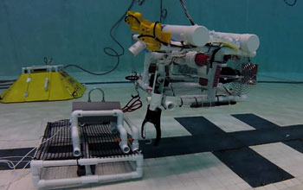

Watch the video that is linked to this page and answer the following questions.

1. How many teams participated in the 2013 competition? _______ teams,

from ____ states

and _____ countries.

1. For the challenge, students were required to design and build a remotely operated underwater vehicle (ROV) for tasks related to operating and maintaining an __________ ________ system.
2. How many years will the actual system be on the ocean floor? _____ years.

Read the article and answer the following questions.

1. What does MATE stand for?
2. What does ROV stand for?
3. What are the 3 things that the teams were evaluated on in this competition?
4. Teams were evaluated on the ___________ , construction and performance of their ROVs
5. Their ability to ________________ what they learned
6. How they put their ______________ to use in designing and building their ROVs.
7. Students were encouraged to think like __________ and manage their teams like ___________.
8. The challenge was based on work being done at the University of ____________.
9. What does STEM stand for?
10. Click on the home tab of the National Science Foundation website. Try to find out more about the NSF’s goals.

The National Science Foundation (NSF) is an independent federal agency created by _______ in _______

"to promote the progress of_______________; to advance the national__________ , _____________, and _______________; to secure the national ________________…"