**TEXTILES, FASHION, AND APPAREL**

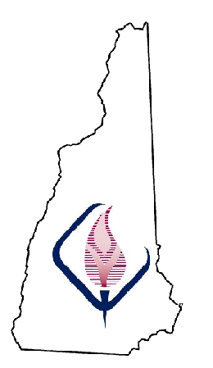

This is an introductory course that will familiarize students with careers in the textile, fashion, and apparel industries and will help them understand personal suitability for success. Students will identify and obtain a working knowledge of fibers, methods of textile construction, and finishing through technology, instruction, discussion, and experimentation. Students will explore past history and current trends. Students will creatively utilize the elements and principles of design to recognize well-designed and constructed textiles as well as explore reasons, identify methods, and demonstrate skills needed for altering, repairing, recycling, and redesigning apparel and/or textile products. This course will also provide opportunities for students to apply communication, leadership, management, and critical thinking skills to all areas of textile development and merchandising. By coordinating classroom theory with hands-on experiences, students develop and enhance their creativity, critical thinking and problem solving skills necessary to be innovative and productive members of society.

**Competencies:**

1. **Analyze** career pathways within textile apparel and design industries.

2. **Demonstrate** fashion, apparel, and textile design skills.

3. **Demonstrate** skills needed to produce, alter, or repair fashion, apparel, and textile products.

4. **Evaluate** elements of textile, apparel, and fashion merchandising.

**Pacing Guide**

* **Career**
* **Fashion apparel, textile design skills, and historical trends**
* **Alter, or repair fashion, apparel, and textile products**
* **Textile, apparel, and fashion merchandising**

**CAREER:**Essential and Enduring Understandings:

* *Understand the variety of job, entrepreneurship, and career opportunities in the fashion, apparel, and the textile industry.*
* *Recognize communication, leadership, management, and critical thinking in the workplace.*

National Standards for Family and Consumer Science:  
16.1.1 Explain the roles and functions of individuals engaged in textiles and apparel careers  
16.1.2 Analyze opportunities for employment and entrepreneurial endeavors

**FASHION, APPAREL, TEXTILE DESIGN SKILLS and HISTORICAL TRENDS:**Essential and Enduring Understandings:

* *Incorporate the elements and principles of design to demonstrate ways in which fiber, fabric, texture, pattern, and finish can affect visual appearance.*
* *Design products that include ecological, environmental, sociological, psychological, technical, economic, historical trends and issues.*

National Standards for Family and Consumer Science:  
*16.3.1 Explain the ways in which fiber, fabric, texture, pattern, and finish can affect visual appearance.*

*16.3.3 Utilize elements and principles of design in designing, constructing, and/or altering textile, apparel, and fashion products*

*16.3.5 Generate design that takes into consideration ecological, environmental, sociological, psychological, technical, and economic trends and issues.*

**ALTER OR REPAIR FASHION, APPAREL, AND TEXTILE PRODUCTS:**Essential and Enduring Understandings:

* *Demonstrate basic and professional skills for producing and altering textile products and apparel.*
* *Utilize current technology and trends to design textile, fashion, and apparel products.*

National Standards for Family and Consumer Science:  
*16.4.1 Demonstrate professional skills in using a variety of equipment, tools, and supplies for fashion, apparel, and textile construction, alteration, and repair.  
16.4.4 Analyze current technology and trends that facilitate design and production of textile, apparel, and fashion products.  
16.4.5 Demonstrate basic skills for producing and altering textile products and apparel*

**TEXTILE, APPAREL, AND FASHION MERCHANDISING:**Essential and Enduring Understandings:

* Investigate marketing strategies within the textile, fashion, and apparel industry.
* Apply marketing methods and forecasting techniques for promoting apparel and textile products.

National Standards for Family and Consumer Science:  
16.5.1 Apply marketing strategies for textile, apparel, and fashion products.  
16.5.5 Critique varied methods for promoting apparel and textile products.  
16.5.6 Apply research methods, including forecasting techniques, for marketing apparel and textile products.